Spiral Freerun – Private Tuition Interest Registration Form

By filling out this document, you are registering your interest in Spiral Freerun’s Private Tuition services. Please fill out the form as accurately as you can and submit it using the form contact form at the bottom of our webpage https://spiralfreerun.com/private-tuition/
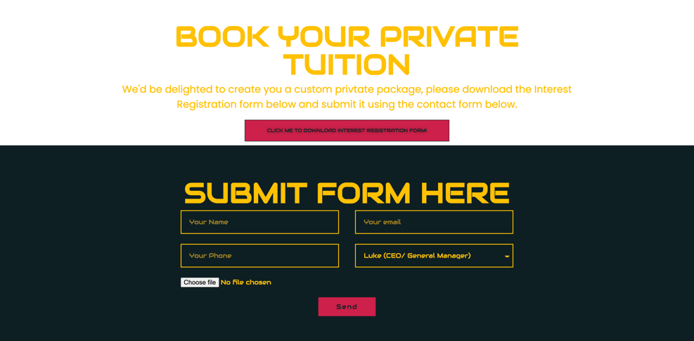

Once submitted, your form will be directed to the coach you have requested who will personally get in contact with you as soon as possible.

Participants Name
Participants DOB
Participant’s Medical Info (please include any neurodiversities, language barriers, physical disabilities or anything that the coaches will need to know to tailor the service accordingly.
Emergency Contact Name (if under 18)
Emergency Contact Number (if under 18)
Email Address
Participant’s Goals
Frequency of Sessions

